

brainstrust BASS BELLE 10km 2025
GETTING THERE

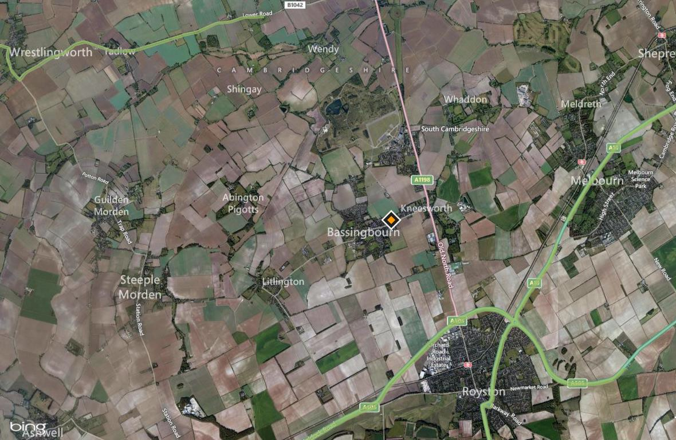

BY CAR:
FROM J10 OF THE M11, HEAD TOWARDS ROYSTON A505 AND THEN TAKE THE A1198 TOWARDS HUNTINGTON. AFTER PASSING THE VILLAGE OF KNEESWORTH, WITH YUVA RESTAURANT ON YOUR RIGHT, GO OVER FIRST MINI ROUNDABOUT AND THEN TAKE LEFT AT NEXT MINI ROUNDABOUT ONTO THE CAUSEWAY. FOLLOW ROAD FOR AROUND A MILE AND THEN AFTER THE WAR MEMORIAL YOU WILL FIND THE CAR PARK AREAS ON YOUR LEFT ON BROOK ROAD. DO NOT USE SOUTH END ROAD FOR ACCESS TO THE EVENT AS THIS IS FOR EVENT STAFF ONLY.
FROM J9 OF THE A1M, HEAD TOWARDS ROYSTON A505. AT THE ROYSTON TESCOS ROUNDABOUT, TAKE FIRST LEFT A1198 TOWARDS HUNTINGTON, THEN FOLLOW INSTRUCTIONS AS ABOVE.

BY TRAIN:
THE CLOSEST STATION TO THE RACE IS ROYSTON STATION (3MILES FROM RACE LOCATION) TRAINS FROM LONDON KING CROSS (45MINS) AND CAMBRIDGE (20MINS)

