brainstrust Bass Belle 10km – Route

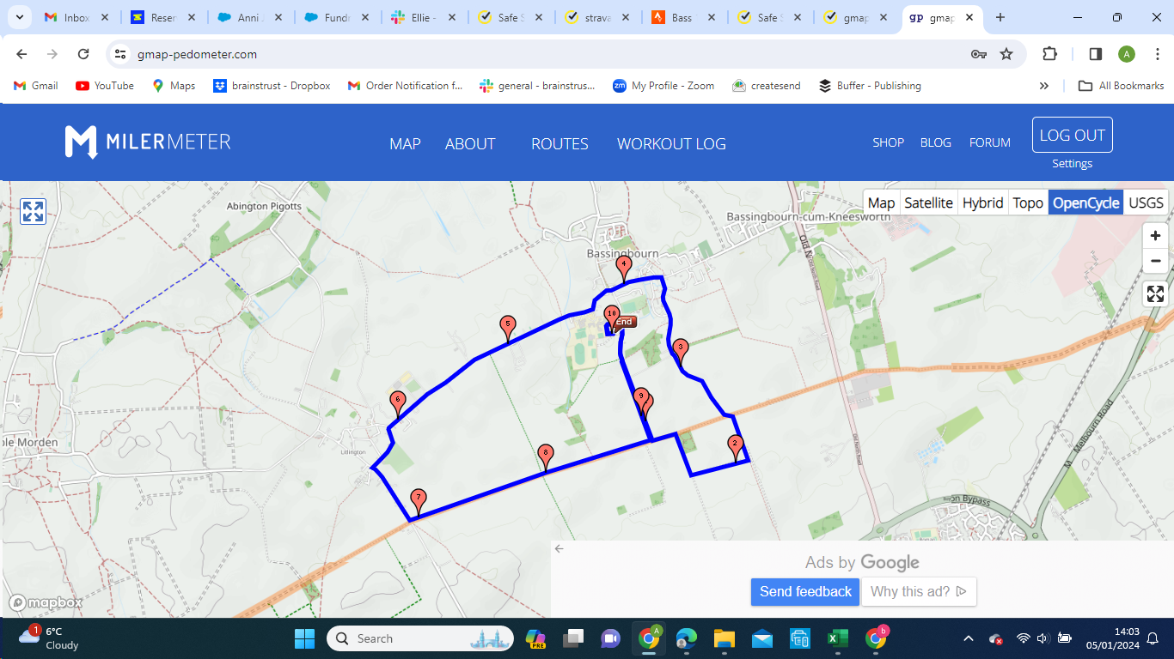
W

