Charity Gift Aid Declaration – multiple donations

Thank you for donating to brainstrust. Your generosity will make a real difference. Did you know that you can boost your donation by 25p for every £1 that you donate through Gift Aid?

Gift Aid is reclaimed by brainstrust from the tax that you pay for the current tax year. All we need is your completed declaration and details of your home address.

Declaration

In order to Gift Aid your donation and any donations that you make in the future to brainstrust, you must tick the box below:

☐ I want to Gift Aid my donation of £ Click here to enter donation amount and any donations I make in the future or have made in the past 4 years to brainstrust.

By ticking the box above, you are agreeing that you are a UK taxpayer and understand that if you pay less Income Tax and/or Capital Gains Tax than the amount of Gift Aid claimed on all of your charitable donations in that tax year, it is your responsibility to pay any difference.

Please note: If you pay Income Tax at the higher or additional rate and want to receive the additional tax relief due to you, you must include all your Gift Aid donations on your Self-Assessment tax return or ask HM Revenue & Customs to adjust your tax code.

Date of Declaration: Click here to enter today’s date

My details

Title: Click here to enter title | First name: Click here to enter first name |  | Surname: Click here to enter surname
Full home address: | Click here to enter full home address
 |  | Home post code: Click here to enter home post code
Please notify brainstrust if you:

- Want to cancel this declaration
- Change your name or home address details
- No longer pay sufficient tax on your Income and/or Capital Gains Tax

Please return this completed form to us:

By email: mailto:hq@brainstrust.org.uk
By post: brainstrust, 4 Yvery Court, Castle Road, Cowes, Isle of Wight, PO31 7QG
You can also complete this form online at brainstrustforms.wufoo.com/forms/gift-aid-form

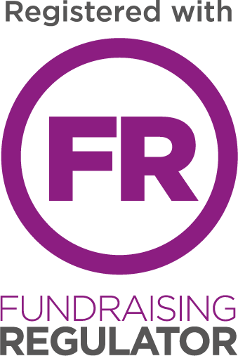

Brainstrust 2017, Registered charity 1114634

